Assignment-2

### Cb.en.u4cse18502

### Hridhi sethi

1. Nested tables

## HTML source code :

<!DOCTYPE html>

<html lang="en">

<head>

<meta charset="UTF-8">

<meta http-equiv="X-UA-Compatible" content="IE=edge">

<meta name="viewport" content="width=device-width, initial-scale=1.0">

<title>Document</title>

</head>

<body>

<style>

h2 {

margin-bottom: 0;

}

</style>

<table border="5px" bordercolor="red" >

<tr>

<td>

<table border="5px" bordercolor="white" >

<h1>Nested Table 2</h1>

<tr padding="10px" >

<td><h3>Column 1</h3></td>

<td><h3>Column 2</h3></td>

</tr>

</table>

<p>Our First Table Nested Within</p>

</td>

<td>

<h1>Nested Table 2</h1>

<ul style="list-style-type:disc;">

<li style="font-size:20px;"><b> List Object 1</b></li>

<li style="font-size:20px;"><b>List Object 2</b></li>

<li style="font-size:20px;"><b>List Object 3</b></li>

</ul>

</td>

</tr>

<tr>

<td>

<h1>Nested Table 3</h1>

<p>

<a href="https://www.google.com/?client=safari" target="_blank">Nested Table</a> Demo Continued.

</p>

</td>

<td>

<h1>Nested Table 4</h1>

<img src="html.PNG" style="border-radius: 20px; height:180px">

</td>

</tr>

</table>

</body>

</html>

## Website

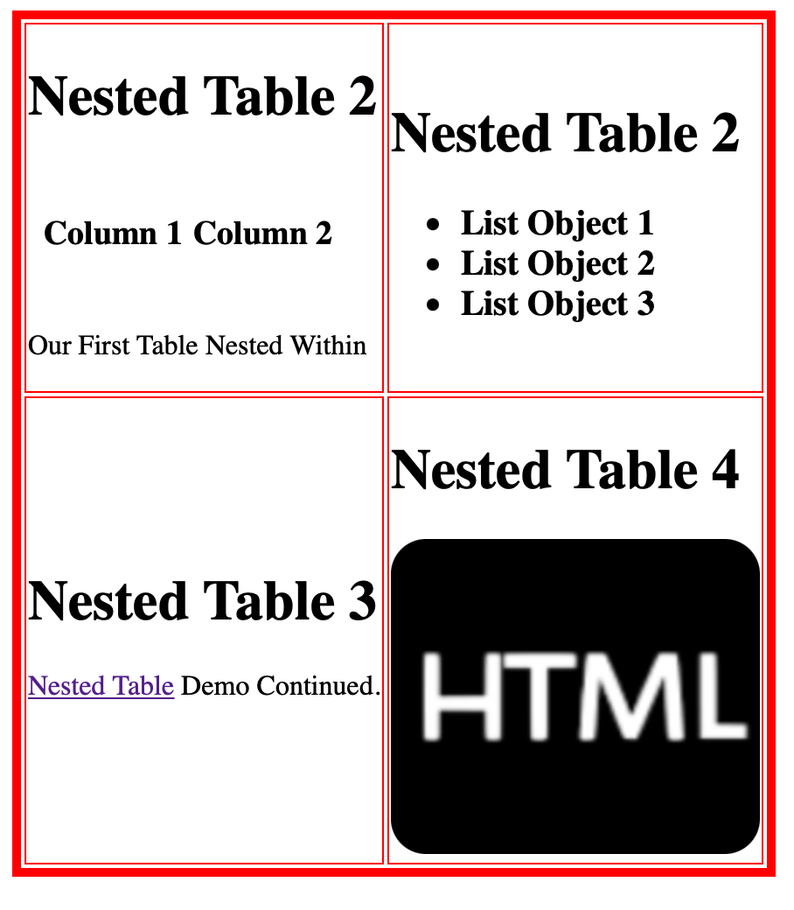

1. Write a HTML program to design the class timetable for IV CSE A/B as given as in a pdf formate

## HTML CODE :

<!DOCTYPE html>

<html lang="en">

<head>

<meta charset="UTF-8">

<meta http-equiv="X-UA-Compatible" content="IE=edge">

<meta name="viewport" content="width=device-width, initial-scale=1.0">

<title>Document</title>

</head>

<body>

<table border="5" cellspacing="0" align="center">

<tr>

<td height="50" align="center" colspan="10" style="background-color: #68BB59">

<B>ONLINE TIME TABLE SLOTS</B>

</td>

</tr>

<tr style="background-color:#FCD12A" >

<td height="50"align="center"><b> Dept:CSE</b></td>

<td height="50"align="center"><b>Semester:VII</b></td>

<td height="50"align="center"><b>Class:B.Tech CSE</b></td>

<td height="50"align="center"><b>Section:A</b></td>

<td height="50"align="center" colspan="3"><b> Class Advisor: Dr. T Senthil Kumar(9842977522) <br> Dr. Madhusudhana Rao Nalluri(8122720522)</b></td>

<td height="50"align="center" colspan="3"><b> Email id:tsenthilkumar@cb.amrita.edu <br> n_madhsudhanarao@cb.amrita.edu</b></td>

</tr>

<tr>

<td height="50"align="center" style="background-color:#FCD12A">Time/Day</td>

<td height="50"align="center">Slot 1 <br><hr border="5"> 8:50am - 9:40am</td>

<td height="50"align="center">Slot 2 <br><hr border="5"> 9:50am - 10:40am</td>

<td height="50"align="center">Slot 3 <br><hr border="5"> 11:00am - 11:50am</td>

<td height="50"align="center">Slot 4 <br><hr border="5"> 12:00pm - 12:50pm</td>

<td height="50"align="center" rowspan="7" style="background-color: rgb(81, 122, 211);">

<b>Lunch Break</b>

</td>

<td height="50"align="center">Slot 5 <br><hr border="5"> 2:00pm - 2:50pm</td>

<td height="50"align="center">Slot 6 <br><hr border="5"> 3:00pm - 3:50pm</td>

<td height="50"align="center">Slot 7 <br><hr border="5"> 4:00pm - 4:50pm</td>

<td height="50"align="center">Slot 8 <br><hr border="5"> 4:30pm - 5:30pm</td>

</tr>

<tr>

<td height="50"align="center" style="background-color:#FCD12A">Monday</td>

<td height="50"align="center">Elective IV </td>

<td height="50"align="center">15CSE401</td>

<td height="50"align="center">soft skills</td>

<td height="50"align="center">15CSE402</td>

<td height="50"align="center" colspan="2">15CSE481 - lab</td>

<td height="50"align="center" style="color: red;">15CSE481 <br> DH</td>

<td height="50"align="center"></td>

</tr>

<tr>

<td height="50"align="center" style="background-color:#FCD12A">Tuesday</td>

<td height="50"align="center">15CSE401</td>

<td height="50"align="center">elective IV </td>

<td height="50"align="center">15CSE402</td>

<td height="50"align="center">Elective V</td>

<td height="50"align="center"></td>

<td height="50"align="center"></td>

<td height="50"align="center"></td>

<td height="50"align="center"></td>

</tr>

<tr>

<td height="50"align="center" style="background-color:#FCD12A">Wednesday</td>

<td height="50"align="center">elective V</td>

<td height="50"align="center"></td>

<td height="50"align="center">15CSE376</td>

<td height="50"align="center">15CSE402 <br> Tutorial</td>

<td height="50"align="center"></td>

<td height="50"align="center"></td>

<td height="50"align="center"></td>

<td height="50"align="center"></td>

</tr>

<tr>

<td height="50"align="center" style="background-color:#FCD12A">Thursday</td>

<td height="50"align="center">Elective IV</td>

<td height="50"align="center">15CSE402</td>

<td height="50"align="center">15CSE401</td>

<td height="50"align="center">15CSE376</td>

<td height="50"align="center"></td>

<td height="50"align="center"></td>

<td height="50"align="center"></td>

<td height="50"align="center"></td>

</tr>

<tr>

<td height="50"align="center" style="background-color:#FCD12A">Friday</td>

<td height="50"align="center">Elective V</td>

<td height="50"align="center"></td>

<td height="50"align="center"></td>

<td height="50"align="center"></td>

<td height="50"align="center" colspan="2">15CSE376 - Lab</td>

<td height="50"align="center"style="color: red;">15CSE376 <br> DH</td>

<td height="50"align="center"></td>

</tr>

<tr>

<td height="50"align="center" style="background-color:#FCD12A">Saturday</td>

<td height="50"align="center" style="color: red;">Elective V <br> DH</td>

<td height="50"align="center" style="color: red;">15CSE402 <br> DH</td>

<td height="50"align="center" style="color: red;">Elective IV <br> DH</td>

<td height="50"align="center"style="color: red;">Mentoring <br> Dr. T Senthil Kumar <br>Dr. Madhusudhana Rao Nalluri</td>

<td height="50"align="center"></td>

<td height="50"align="center"></td>

<td height="50"align="center"></td>

<td height="50"align="center"></td>

</tr>

</table>

<br>

<table border="5" cellspacing="0" align="center">

<tr>

<td height="10"align="center" colspan="3" style="background-color: #68BB59"><b>Theory</b></td>

</tr>

<tr>

<td height="10" align="center" width="150" style="background-color:#FCD12A""><b>Course Code</b></td>

<td height="10" align="center" width="300"style="background-color:#FCD12A"><b>Corse Name</b></td>

<td height="10" align="center" width="200"style="background-color:#FCD12A"><b>Faculty</b></td>

</tr>

<tr>

<td height="20" width="150" >15CSE402</td>

<td height="20"width="300">Structure and Interpretation of computer</td>

<td height="20" width="200">Dr Ragesh Krishnan K</td>

</tr>

<tr>

<td height="20" width="150" >15CSE401</td>

<td height="20" width="300">Machine learning and data mining</td>

<td height="20" width="200">Dr. T R Swapna</td>

</tr>

<tr>

<td height="20"width="150" >15CSE376</td>

<td height="20" width="300">Net centric Programming</td>

<td height="20" width="200">dr C Anukumar</td>

</tr>

<tr>

<td height="10"align="center" colspan="3" style="background-color: #68BB59"><b>ELECTIVE IV</b></td>

</tr>

<tr>

<td height="10" width="150" style="background-color:#FCD12A"><b>Course Code</b></td>

<td height="10" width="300"style="background-color:#FCD12A"><b>Corse Name</b></td>

<td height="10" width="200"style="background-color:#FCD12A"><b>Faculty</b></td>

</tr>

<tr>

<td height="20" width="150" >15CSE331</td>

<td height="20" width="300">Advanced Algorithm analysis</td>

<td height="20" width="200">Ms M pratilotamai</td>

</tr>

<tr>

<td height="20"width="150">15CSE343</td>

<td height="20" width="300">Design Patterns</td>

<td height="20" width="200">Dr N lalithamani</td>

</tr>

<tr>

<td height="20" width="150" >15CSE358</td>

<td height="20" width="300">Nalural Language processing</td>

<td height="20" width="200">Dr. Manu madhavan</td>

</tr>

<tr>

<td height="20" width="150" >15CSE351</td>

<td height="20" width="300">Information Security</td>

<td height="20" width="200">Dr N radhika</td>

</tr>

<tr>

<td height="5" colspan="3" align="center"style="background-color: #68BB59"><b>ELECTIVE V</b></td>

</tr>

<tr>

<td height="5" width="150" style="background-color:#FCD12A"><b>Course Code</b></td>

<td height="5" width="300"style="background-color:#FCD12A"><b>Corse Name</b></td>

<td height="5" width="200"style="background-color:#FCD12A"><b>Faculty</b></td>

</tr>

<tr>

<td height="20" width="150" >15CSE360</td>

<td height="20" width="300">Parellel and distributed computing</td>

<td height="20" width="200">Ms Vidhya S</td>

</tr>

<tr>

<td height="20" width="150" >15CSE370</td>

<td height="20" width="300">Wireless and mobile communication</td>

<td height="20" width="200">Dr N radhika</td>

</tr>

<tr>

<td height="20" width="150" >15CSE480</td>

<td height="20" width="300">Internet of Things</td>

<td height="20" width="200">Dr. Gowtham <br> Mr A bhaskar <br> Mr A K Sumesh </td>

</tr>

</table>

<table border="5" cellspacing="0" style="position:absolute; left:1000px; top:1020px" >

<tr>

<td height="20"align="center" colspan="4" style="background-color: #68BB59">LAB</td>

</tr>

<tr>

<td height="20"width="150" style="background-color:#FCD12A"><b>Course Code</b></td>

<td height="20" width="300" style="background-color:#FCD12A"><b>Course Name</b></td>

<td height="20" width="200" style="background-color:#FCD12A""><b>Faculty</b></td>

<td height="20" width="200"style="background-color:#FCD12A"><b>Assisting</b></td>

</tr>

<tr>

<td height="50">15CSE481</td>

<td height="50">Machile learning and Data mining</td>

<td height="50">Dr T R Swapna</td>

<td height="50">Dr lalithamani <br> Mr. Prabhu P</td>

</tr>

<tr>

<td height="50">15CSE376</td>

<td height="50">Net Centric Programming</td>

<td height="50">Dr C ArunKumar</td>

<td height="50">Ms R Majusha <br> Ms Divya Bharati</td>

</tr>

<tr>

<td height="50">15CSE480</td>

<td height="50">Internet of Things</td>

<td height="50">Dr R Gowtham</td>

<td height="50">Dr. Madhusudhana Rao Nalluri <br> Ms. G R Ramya</td>

</tr>

<tr>

<td height="50">15CSE480</td>

<td height="50">Internet of Things</td>

<td height="50">Mr A Bhaskar</td>

<td height="50">Mr. B A Sabarish <br> Mr Raghul</td>

</tr>

<tr>

<td height="50">15CSE480</td>

<td height="50">Internet of Things</td>

<td height="50">Mr A K Sumesh</td>

<td height="50">Dr. P Bagavathi Sivakumar <br> Ms R Sujee <br> Dr. M Anbazhagan <br> Ms Divya Bharati</td>

</tr>

</table>

</body>

</html>

## Website :

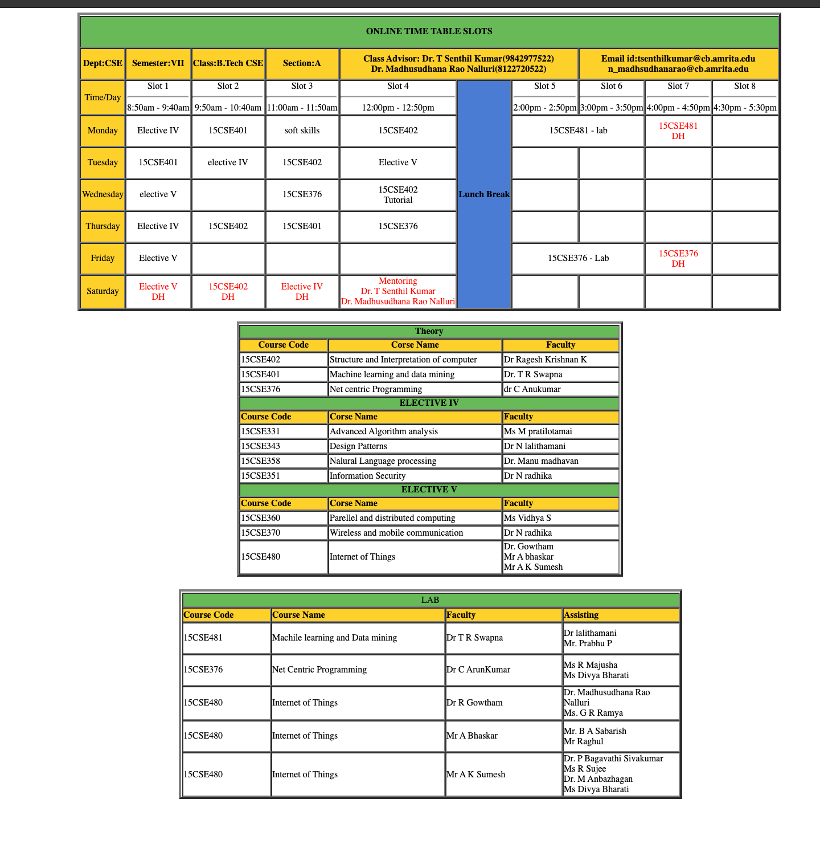

1. Write a HTML program to use the concepts of image maps

## HTML code

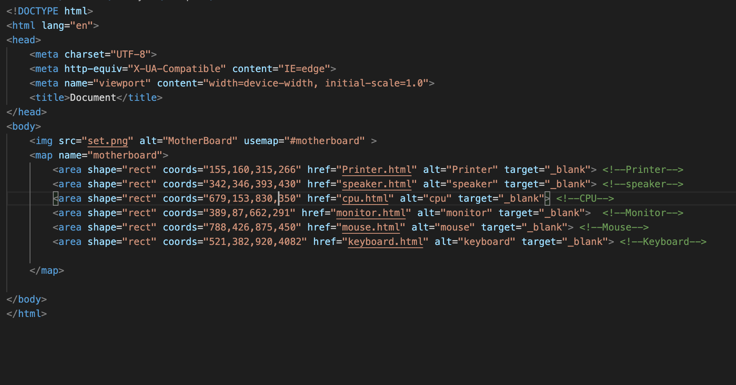

## Keyboard

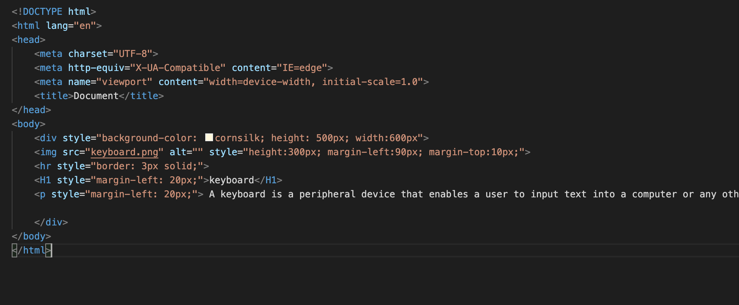

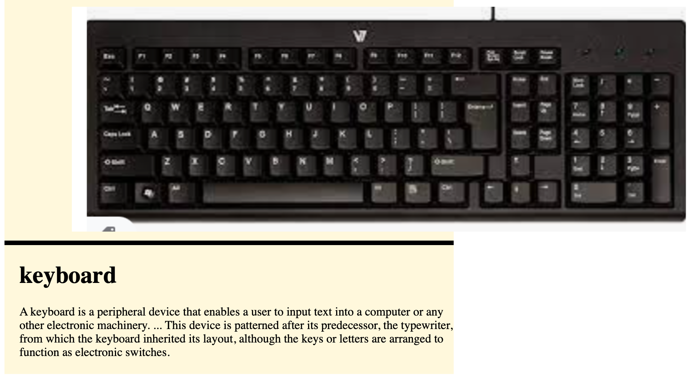

## Mouse

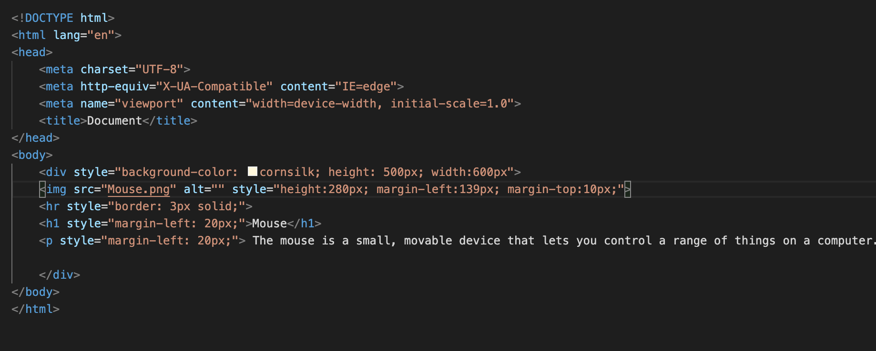

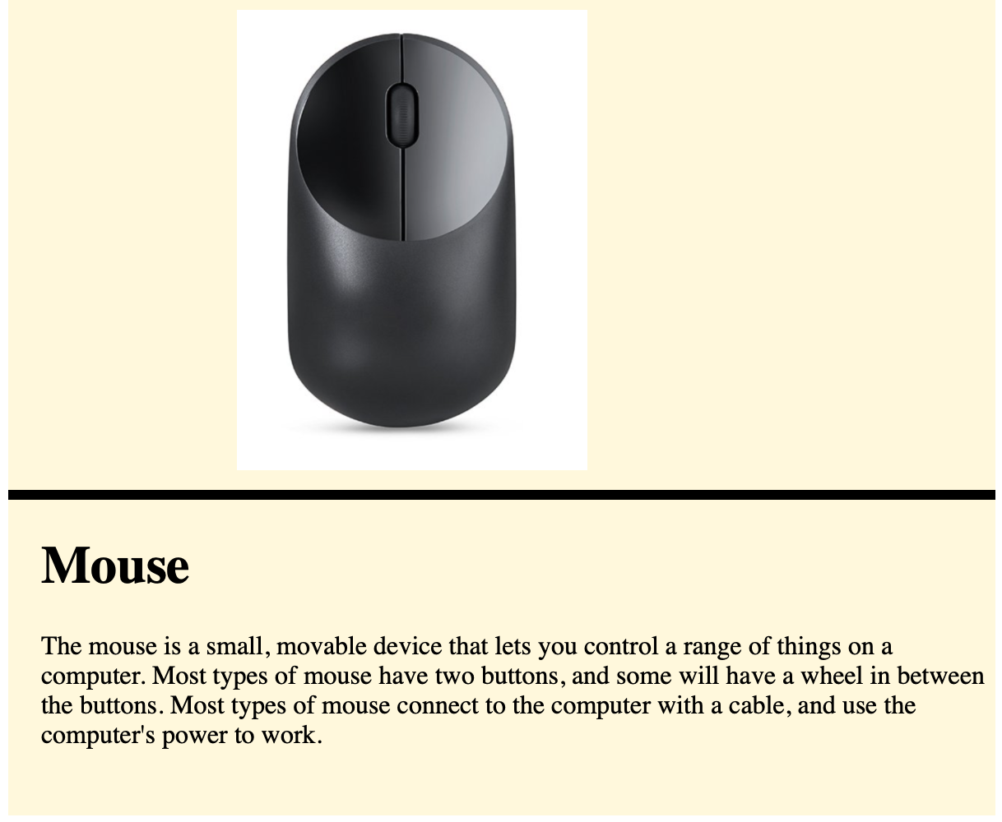

## Monitor

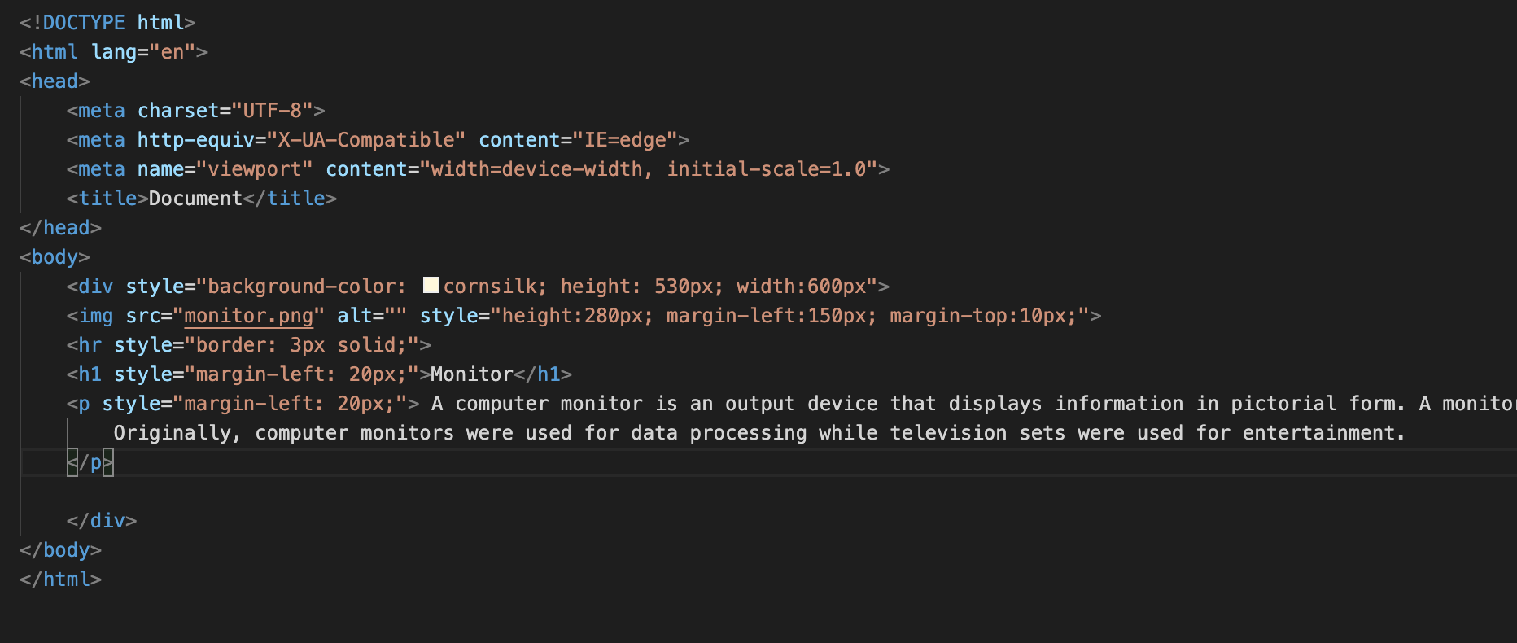

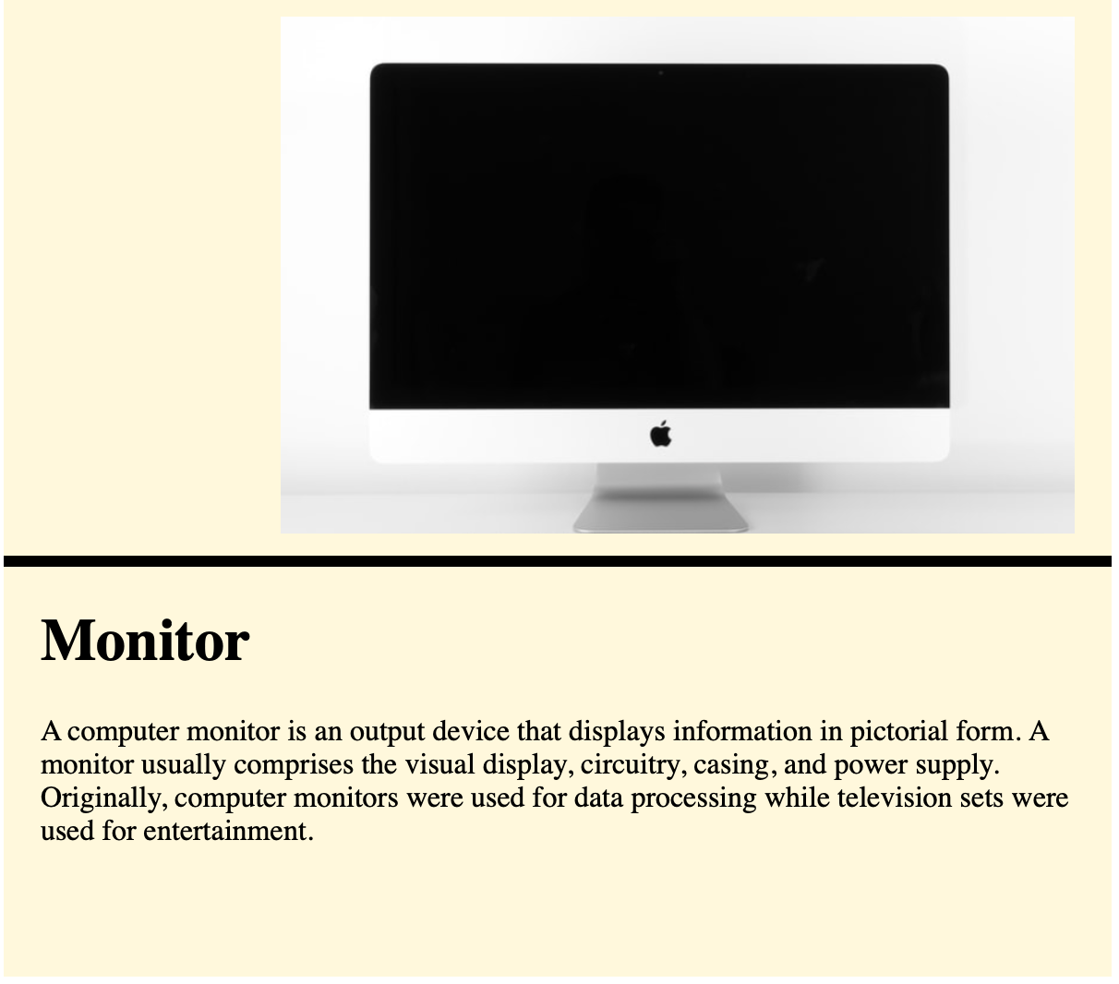

## Speaker

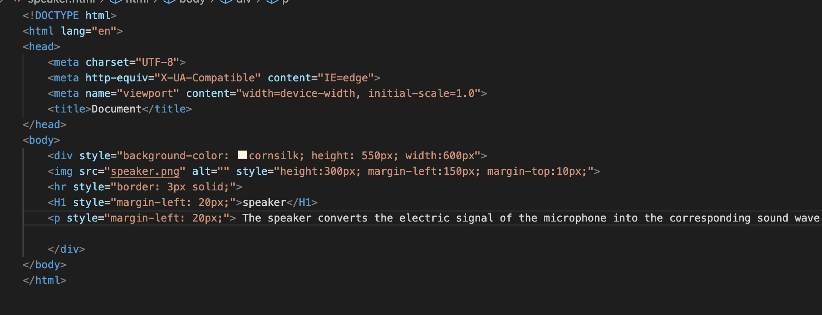

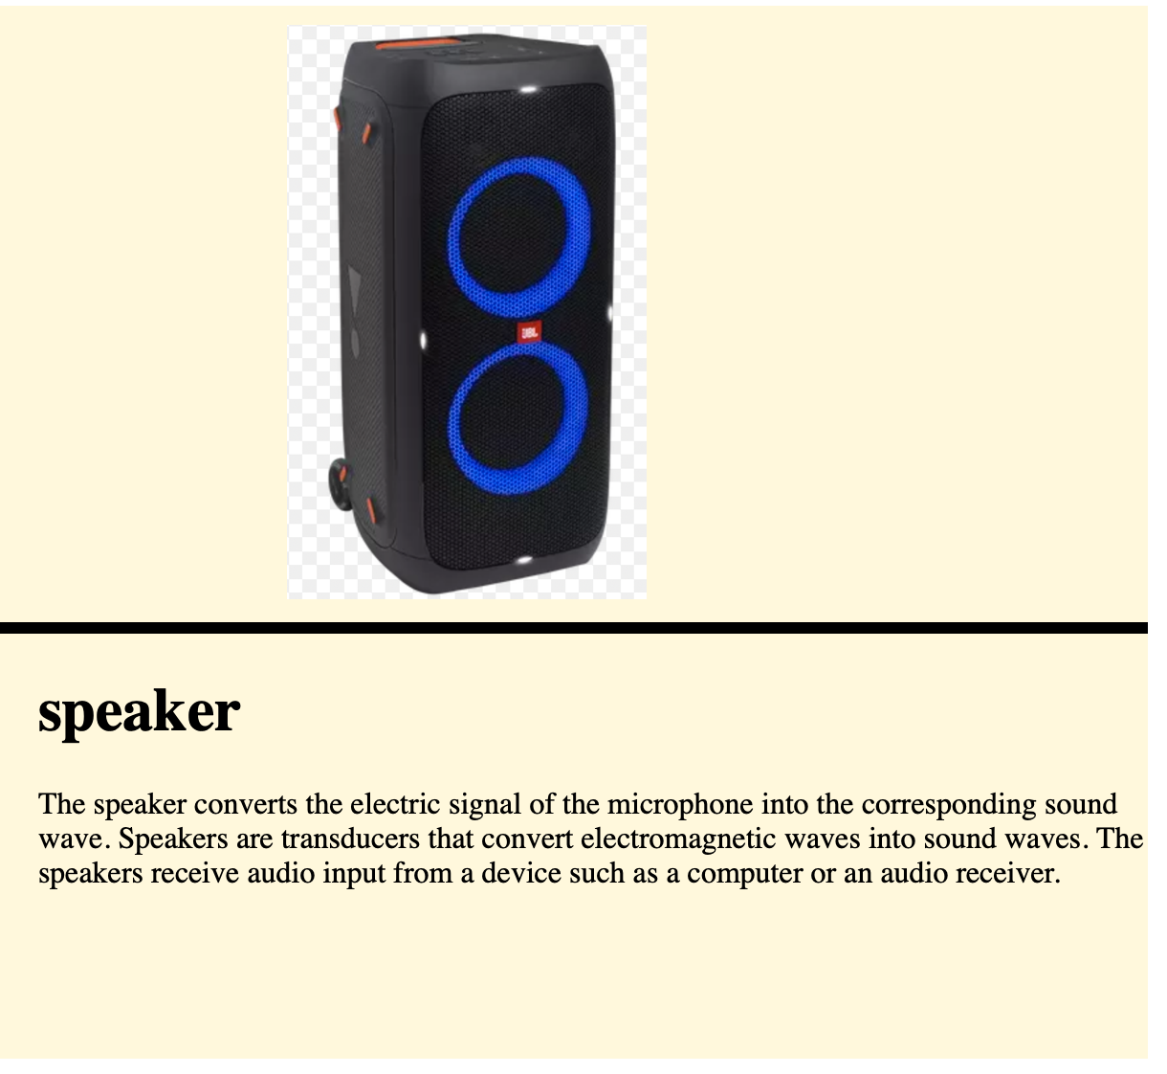

## Printer

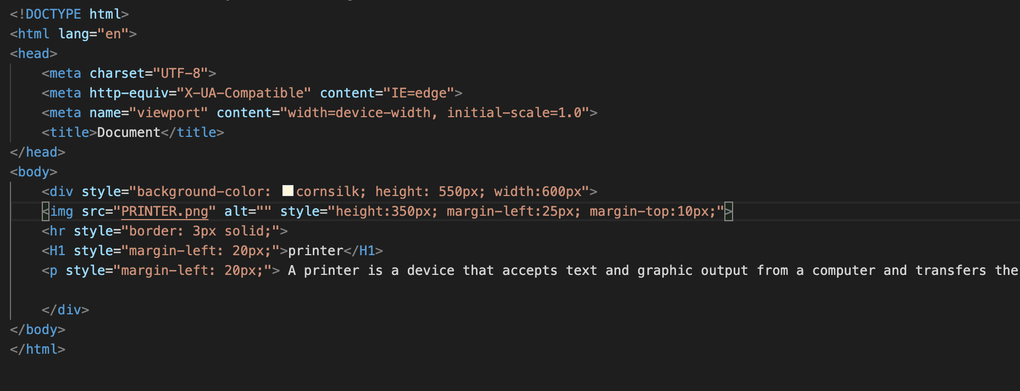

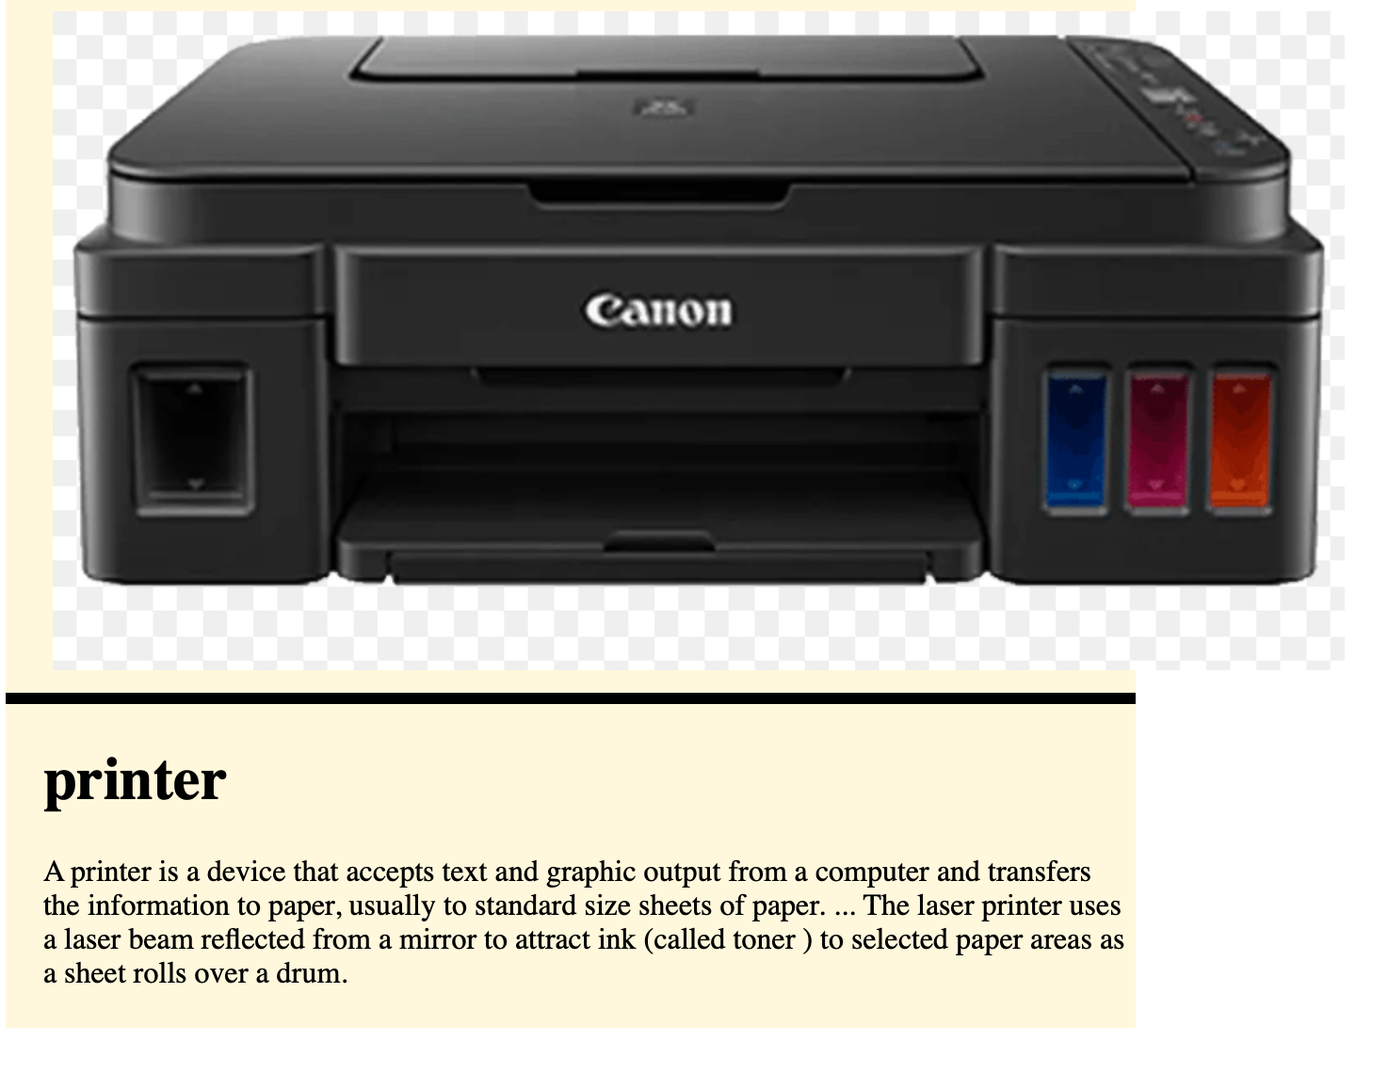

## CPU

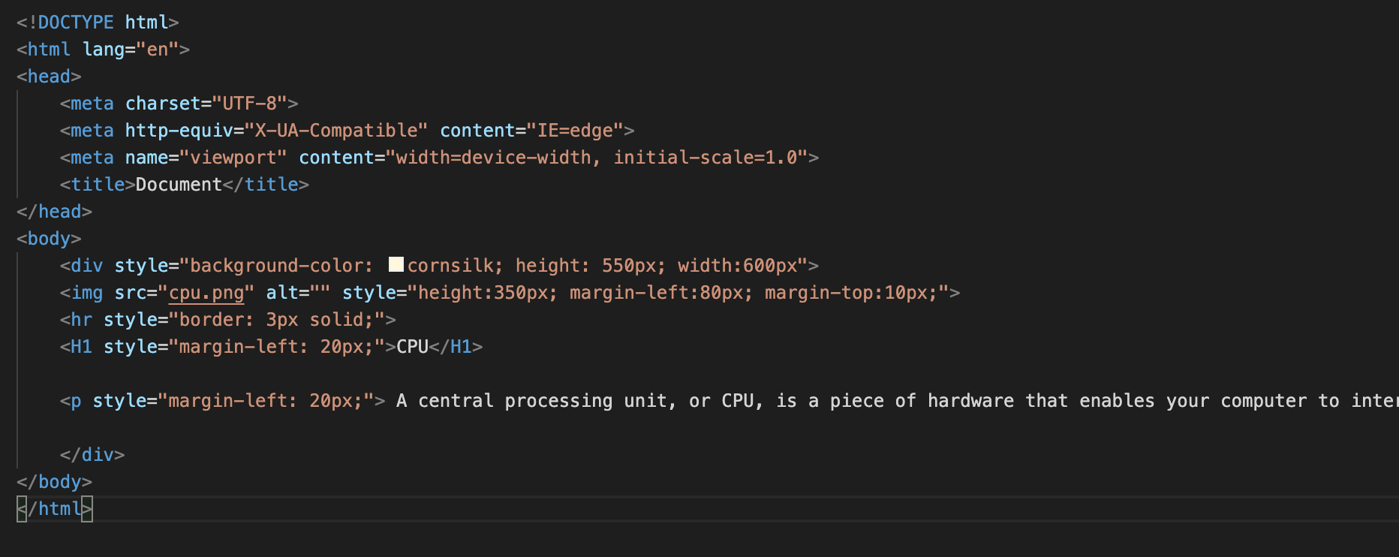

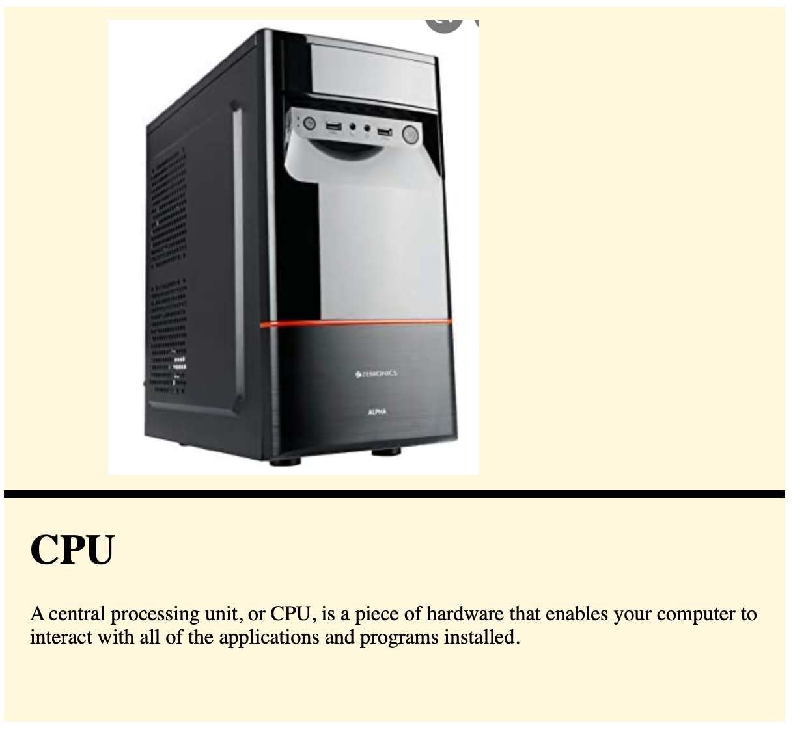

## Website

